Data Engineering Design Proposal for Precision Components Inc.

Part I: Business Case Analysis
A1. Problem Statement
Precision Components Inc. is facing significant data integration challenges as the company grows and expands its operations. The recent acquisition of SmallFirm, Inc. has introduced incompatible legacy systems into the organization, with data currently managed in a combination of Microsoft Access databases, Excel spreadsheets, SQL Server-based ERP systems, and a hosted Oracle HR/payroll platform. The organization currently lacks a centralized data warehouse or unified dashboard solution, limiting its ability to make timely, data-driven decisions. Current manual reporting processes introduce an average delay of 48 hours between data capture and executive review, reducing Precision Components’ ability to react to production or inventory issues in real time.
Business requirements include:
- Merging SmallFirm's data into existing systems while maintaining data integrity.
- Establishing automated data ingestion processes that run daily or nightly.
- Consolidating data across ERP, HR, sales, and inventory systems into a centralized warehouse.
- Providing real-time reporting capabilities through interactive dashboards.
- Ensuring the system is scalable to support future growth and international expansion.
- Unifying siloed sales data for enterprise-wide sales analysis.
- Maintaining strict compliance with industry data security and privacy regulations.
Addressing these needs will require a comprehensive, scalable, cloud-based data architecture that integrates disparate data sources into a single, governed data platform.

A2. Source-to-Target Data Mapping
A2a. Define the Attributes
Source Entity | Attributes | Target Data Warehouse Entity | Target Attributes
Payroll | ID, EmployeeId, Salary, PayDate | Payroll Fact Table | PayrollID, EmployeeID, Salary, PayDate
Personnel | ID, First Name, Last Name, Position, HireDate | Employee Dimension Table | EmployeeID, FirstName, LastName, Position, HireDate
Vendors | ID, Name, AccountRep, Status | Vendor Dimension Table | VendorID, VendorName, AccountRep, Status
Products | ProductID, Name, Cost, SalePrice, RawMaterials, Tooling | Product Dimension Table | ProductID, ProductName, Cost, SalePrice, RawMaterials, Tooling
Production Batch | BatchNumber, ProductionDate, ProductID, QuantityProduced | Production Fact Table | BatchNumber, ProductionDate, ProductID, QuantityProduced
Tooling Inventory | ID, ToolName, Quantity, Location, Cost, RestockLevel, VendorID | Tooling Dimension Table | ToolID, ToolName, Quantity, Location, Cost, RestockLevel, VendorID
Raw Materials Inventory | ID, MaterialName, Quantity, Unit, RestockLevel, VendorID | Raw Materials Dimension Table | MaterialID, MaterialName, Quantity, Unit, RestockLevel, VendorID
A2b. Map the Attributes
The ETL processes will map each source attribute to its corresponding target attribute based on consistent business rules. For example, the Personnel table’s ID field will map to EmployeeID in the Employee Dimension Table, and Vendor table’s ID field will map to VendorID in the Vendor Dimension Table.
A2c. Describe Necessary Data Transformations
- Data Cleansing: Standardize formats, resolve data entry errors, and handle missing values.
- Data Type Conversion: Convert fields to appropriate formats (e.g., numeric, date, string).
- Deduplication: Eliminate duplicate records, particularly for employees, vendors, and products.
- Surrogate Key Generation: Use auto-generated keys to create surrogate primary keys for dimension tables.
- Normalization: Align currencies, units of measure, and naming conventions across datasets.
- Conflict Resolution: Apply predefined business rules for resolving data conflicts during the merger.

Part II: Recommended Design Solution
B1. Process Flow Diagram
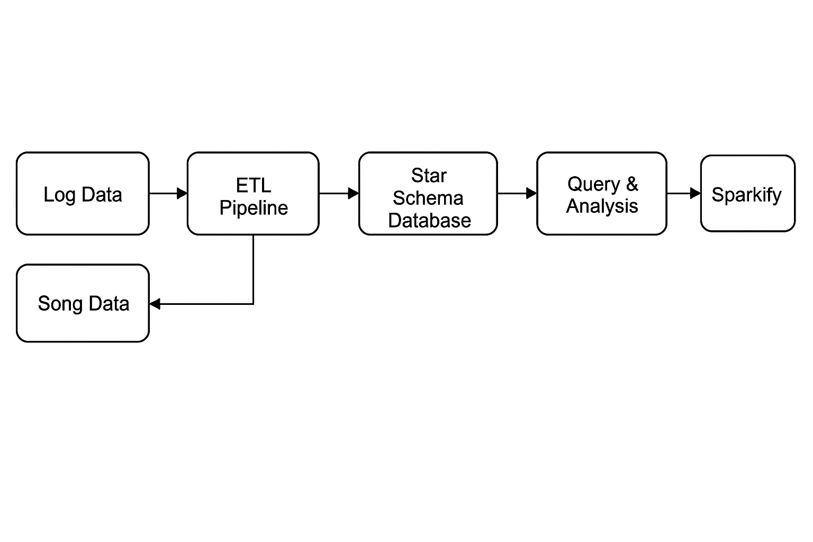
The following outlines the proposed solution’s process flow:
- Data Extraction
  - Use ETL tools (e.g., AWS Glue, Apache NiFi, Azure Data Factory) to extract data from MS Access and Excel sources.
- Staging Layer
  - Load extracted data into Amazon S3 as raw data files.
- Data Transformation and Loading
  - Use Apache Airflow to orchestrate jobs.
  - Load staging data into Amazon Redshift using COPY commands.
  - Apply SQL transformations to populate fact and dimension tables.
- Data Quality Checks
  - Execute automated data quality validations using Airflow operators.
- Data Warehouse Storage
  - Store curated data in Redshift (or equivalent cloud data warehouse).
- Reporting and Dashboards
  - Connect BI tools such as Power BI or Tableau to the data warehouse.
- Monitoring and Governance
  - Leverage Airflow logs, security monitoring, and audit trails to ensure data governance and compliance.
B2. Level 1 Logical Data Flow Diagram
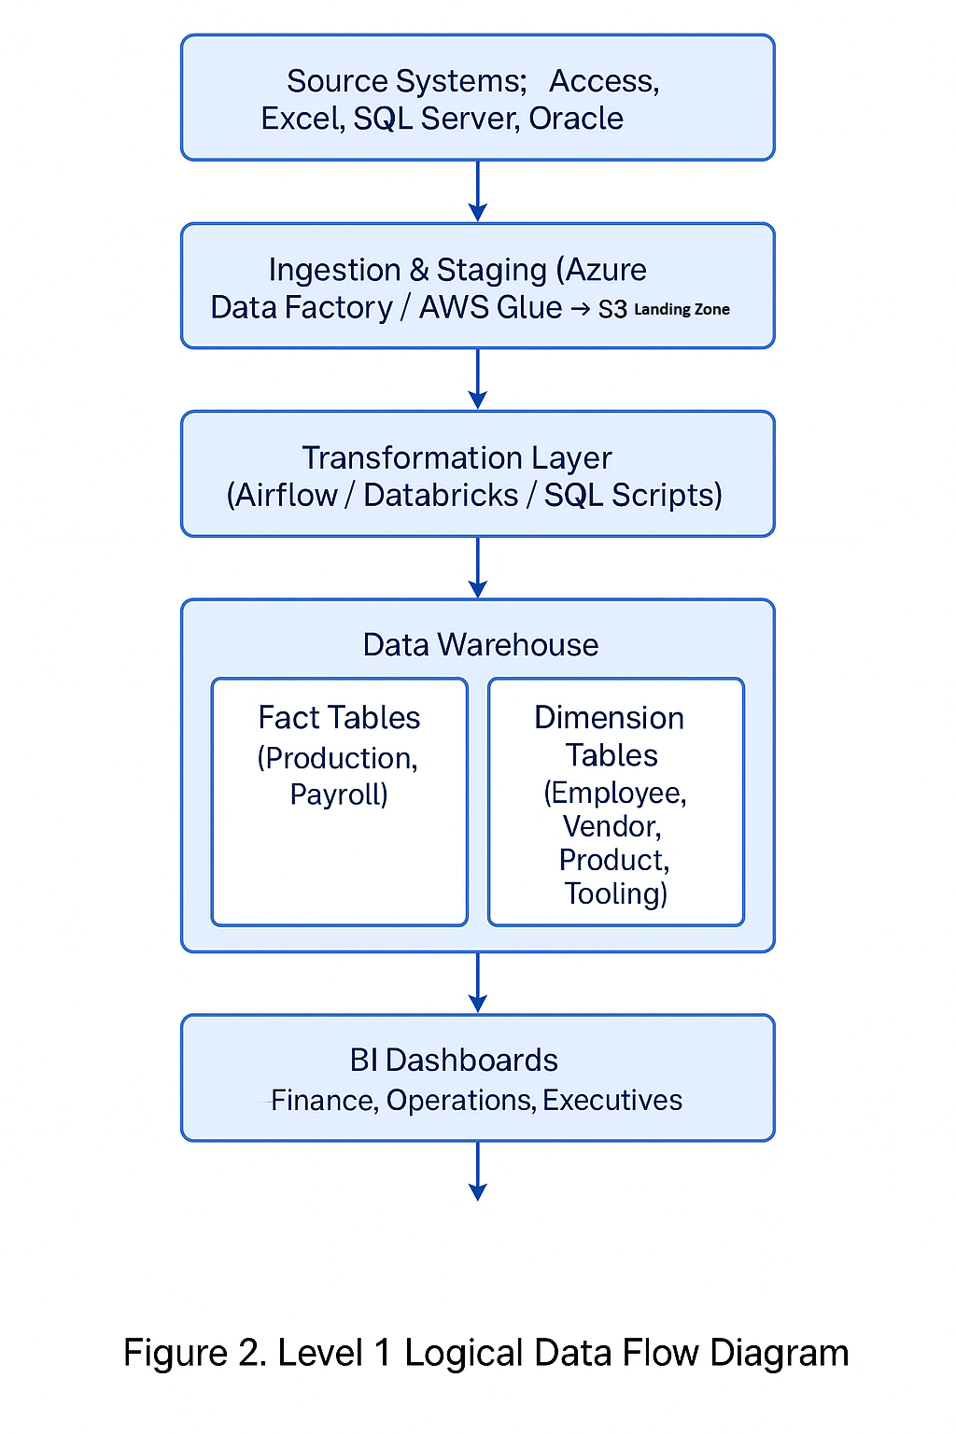
The Level 1 diagram shows how raw operational data is ingested from multiple source systems, processed through ETL and transformation layers, and delivered to fact and dimension tables for business intelligence consumption.

Part III: Processing Design Evaluation
C1. Advantages of the Proposed Design
- Scalability and Flexibility
The cloud-native architecture allows Precision Components Inc. to scale seamlessly as the company grows. New data sources and increased data volumes can be accommodated without significant re-architecture (Reis & Housley, 2022).
- Unified View of Business Operations
Integrating data from all operational systems into a centralized warehouse provides leadership with a single source of truth for reporting and analytics (Automated Data Pipelines Training course, n.d.).
- Operational Efficiency
Apache Airflow enables automated scheduling, orchestration, and monitoring of ETL processes, significantly reducing manual labor and the risk of human error.
- Strong Data Governance
A unified system allows for centralized enforcement of security protocols, regulatory compliance, and data quality controls (Reis & Housley, 2022).
C2. Disadvantages of the Proposed Design
- Implementation Complexity
The initial design and deployment of cloud-based pipelines require substantial technical expertise, staff training, and time investment (Automated Data Pipelines Training course, n.d.).
- Ongoing Costs
Cloud services introduce recurring costs related to compute, storage, and data transfer, which must be carefully monitored and optimized.
- Integration of Legacy Systems
Migrating data from older systems such as MS Access and Excel may require custom connectors or intermediary data extraction layers.
- Monitoring Overhead
Continuous monitoring of Airflow pipelines, job failures, and data quality metrics will require dedicated operational oversight.

References
Reis, J., & Housley, M. (2022). Fundamentals of data engineering. O’Reilly Media.
Udacity. (n.d.). Automate data pipelines [Online course]. Udacity. Retrieved October 24, 2025, from https://www.udacity.com/course/automate-data-pipelines--cd12380

